**Quaid i Azam University Islamabad**



**Multimedia and Computer Graphics**

**Assignment**

**Project Final Module**

**Members**

**Muhammad Munir Khan**

**Farukh Ahmed**

**Faizan Abbas**

**Game Idea**

Create a Kart racing Unity game where players race through iconic Mushroom Kingdom tracks, collect power-ups, and compete against friends. Customize karts with unique abilities, embark on challenging adventures, and aim for victory in a visually engaging and immersive kart racing experience.

**Game Storyline**

In Mushroom Kingdom Rivals, a racer wants to win the big Mushroom Kingdom race. But bad guys led by Bowser try to mess it up. The racer teams up with friends, stops Bowser, saves Princess Peach, and wins the race to bring back peace.

**Game Story**

The story of the game Kart Racer is that first of all there are different tracks available and user has to pick one of the tracks in which the user does racing with their opponents. Lots of really good racers from everywhere are joining in means there are total of 8 racers who are participating in the race. The tracks are so good, tracks are having some hurdles so it’s a great competition between the users and users earns points by collecting coins and collect different things like banana peel and mushrooms. There are 2 to 3 laps for each track. This is kart race and those who complete the laps early will win the game.

**Game Logic**

**Game Environment/Arena:**

The game is providing a variety of vibrant and challenging race tracks, each with its own unique layout and obstacles/hurdles and have an amazing animation and good sound track. The tracks are named as Moo Moo Meadows, Rainbow Road, Water Park and Toad Harbor.

**Game type:**

Kart Racer Game is a fast-paced, kart-racing game that combines arcade-style racing with strategic item usage. Players compete against each other in a series of races, aiming to finish first.

**Language for extra action, rewards:**

The language of the game is English as it’s an international language and everybody can understand it easily. Players can collect a variety of power-up items scattered throughout the tracks, each providing a unique advantage. These items include speed boosts, and flying jet.

**Rewards:**

Players earn points for finishing races in high positions and collecting coins scattered throughout the tracks.

**Character details**

* Baby Mario
* Lemmy
* Luigi
* Peach
* Mario
* Shyguy

**Levels and scoring system**

The game features a total of 3 tracks, divided into 3 laps. Each track has three laps and has its own hurdles and obstacles and users has to collect coins and other things while scattering throughout the tracks.

**Scoring system:**

Players earn points based on their finishing position in each race. Players also earn points for collecting coins scattered throughout the tracks.

**Additional features**

* A soundtrack of catchy tunes to keep you pumped up.
* Beautiful animation had been used.
* We are using 8k skybox pack for sky scenes.
* Camera should be good focused.

**Game Screenshots**

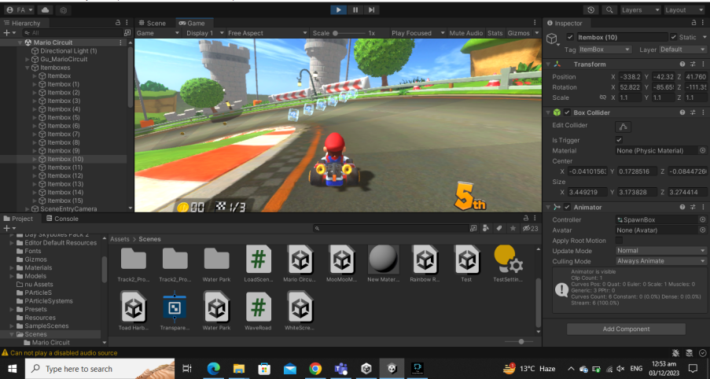

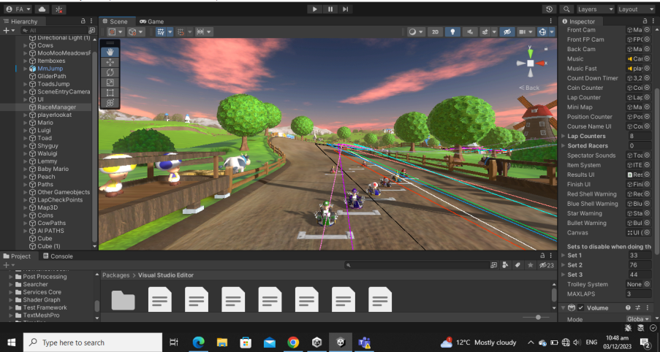

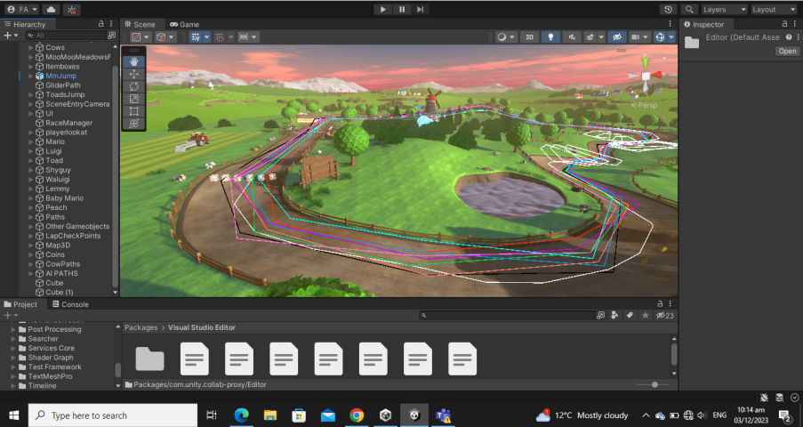

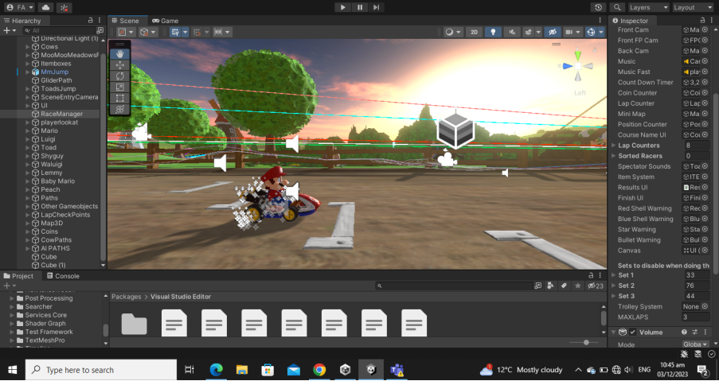

**Code Screenshots**

